Name - Gaurang A Raorane Div - D15A Roll no - 49 Batch - C

Experiment - 10

**Aim -** To study and implement deployment of Ecommerce PWA to GitHub Pages

**Theory -**

GitHub Pages and Firebase are both excellent platforms for hosting websites and web applications, each with its own set of features, advantages, and limitations. Here's a comparison of the two:

GitHub Pages:

Pros:

1. Familiar interface for GitHub users.

2. Easy setup process.

3. Supports Jekyll for blogging out of the box.

4. Allows custom domains.

Cons:

1. Website code is public unless using a private repository.

2. No HTTPS support for custom domains (currently).

3. Limited plugin support for Jekyll.

Firebase:

Pros:

1. Hosted by Google, ensuring reliability and scalability.

2. Offers authentication, cloud messaging, and other useful services.

3. Provides a real-time database and blob store.

4. HTTPS support with free SSL certificate provisioned for custom domains.

Cons:

1. Limited to 10 GB of data transfer per month.

2. Command-line interface only.

Reasons to Choose GitHub Pages:

1. Free to use and integrates seamlessly with GitHub repositories.

2. Easy setup process, particularly for static websites.

3. Great for hosting blogs with Jekyll.

4. Supports custom domains.

Reasons to Choose Firebase:

1. Real-time backend capabilities make it suitable for dynamic and collaborative applications.

2. Provides a broader range of services beyond hosting, such as authentication and cloud messaging.

3. HTTPS support and free SSL certificates for custom domains.

4. Hosted by Google, ensuring reliability and scalability.

In summary, GitHub Pages is a great choice for static websites, particularly for users already familiar with GitHub, while Firebase offers a more comprehensive platform for building dynamic and real-time applications with additional backend services. Your choice should depend on the specific needs and requirements of your project.

**Screenshot -**

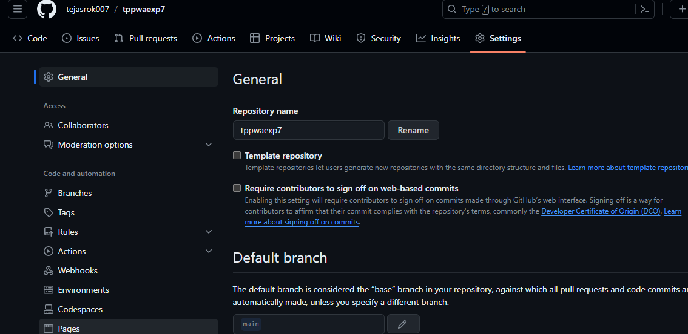



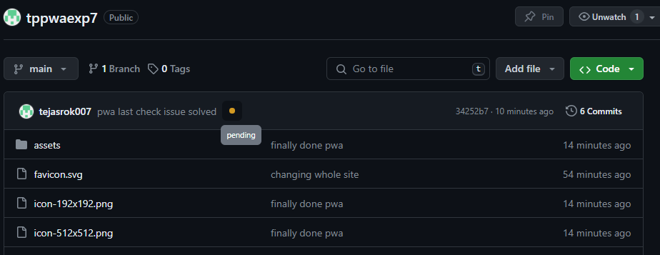

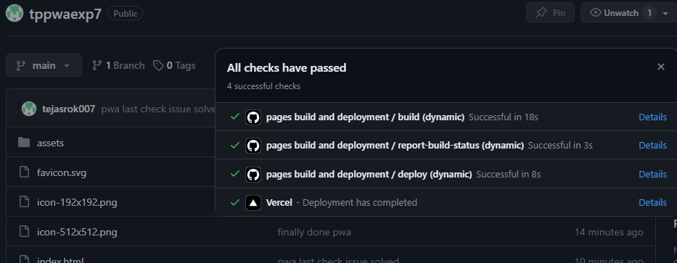

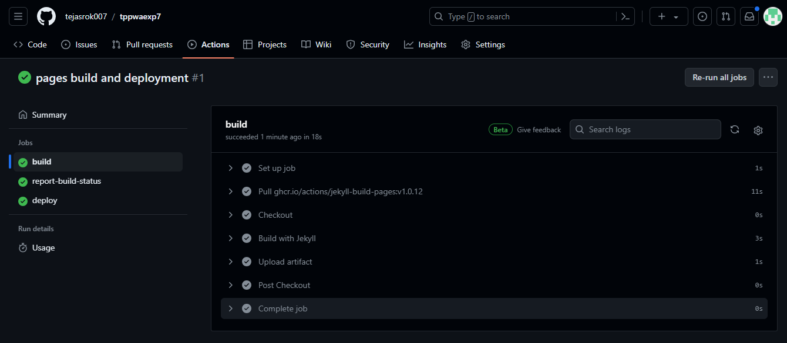







Github - <https://tejasrok007.github.io/tppwaexp7/>

Conclusion -

In this experiment, we have registered a service worker, and completed the install and activation process for a new service worker for the E-commerce PWA.